Multi Area OSPF in a Nutshell

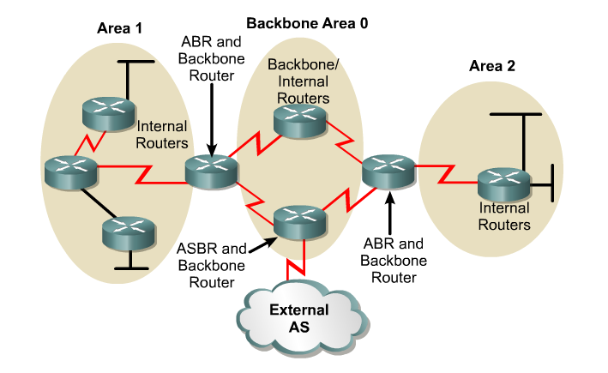

Internal: Routers with all their interfaces within the same area  Backbone: Routers with at least one interface connected to area 0  ASBR: (Autonomous System Boundary Router): Routers that have at least one interface connected to an external internetwork (another autonomous system)  ABR: (Area Border Router): Routers with interfaces attached to multiple areas.  Normal Areas  Receives all routes from within A.S.:  - Within the local area – LSA 1 and LSA 2  - From other areas (Inter-Area) – LSA 3, LSA 4, LSA 5  Receives all routes from External A.S.’s (External AS means routes not from this OSPF routing domain):  - From external AS’s – LSA 5  - As long as routes are being redistributed by the ASBR  Default Routes  - Received only if default-information-originate command was used (later)  - If default-information-originate command is not used, then the default route is not received | Stub Area  Receives all routes from within A.S.:  - Within the local area - LSA 1s and LSA 2s (if appropriate)  - From other areas (Inter-Area) - LSA 3s  Does not receive routes from External A.S. (External Routes).  ABR:  - ABR blocks all LSA 4s and LSA 5s.  - ‘If LSA 5s are not known inside an area, LSA 4s are not necessary.’  - LSA 3s are propagated by the ABR.  Note: Default route is automatically injected into stub area by ABR  External Routes: Once the ABR gets a packet headed to a default route, it must have a default route, either static or propagated by the ASBR via default information originate (coming!)  Configuration:  All routers in the area must be configured as “stub”  router ospf 1  network command  area 1 stub

Totally Stubby  Receives routes from within A.S.:  - Only from within the local area - LSA 1s and LSA 2s (if appropriate)  - Does not receive routes from other areas (Inter-Area) - LSA 3s  Does not receive routes from External A.S. (External Routes)  ABR:  - ABR blocks all LSA 4s and LSA 5s.  - ABR blocks all LSA 3s, except propagating a default route.  - Default route is injected into totally stubby area by ABR.  Configuring:  - All routers must be configured as “stub”  - ABR must be configured as “stub no-summary”  NSSA  - NSSA allows an area to remain a stub area, but carry external routing information (Type 7 LSAs) from its stubby end back towards the OSPF backbone.  - ASBR in NSSA injects external routing information into the backbone and the NSSA area, but rejects external routing information coming from the ABR.  - The ABR does not inject a default route into the NSSA.  - This is true for a NSSA Stub, but a default route is injected for a NSSA Totally Stubby area.  - Note: RFC 1587, “A default route must not be injected into the NSSA as a summary (type-3) LSA as in the stub area case.”  Configuraton all routers  - area 2 nssa  Virtual Links  - A virtual link has the following two requirements:  - It must be established between two routers that share a common area and are both ABRs.  - One of these two routers must be connected to the backbone.  area <area-id> virtual-link <remote-router-id> | Inter-Area Route Summarization - Area Range  - By default ABRs do not summarize routes between areas.  - This feature causes a single summary route to be advertised to other areas by an ABR.  - In OSPF, an ABR will advertise networks in one area into another area.  - If the network numbers in an area are assigned in a way such that they are contiguous, you can configure the ABR to advertise a summary route that covers all the individual networks within the area that fall into the specified range.  - On the ABR (Summarizes routes before injecting them into different area)  - Router(config-router)# area area-id range network-address subnet-mask  - area-id - Identifier of the area about which routes are to be summarized. (From area)  External Route Summarization - summary-add  - When redistributing routes from other protocols into OSPF (later), each route is advertised individually in an external link state advertisement (LSA).  - However, you can configure the Cisco IOS software to advertise a single route for all the redistributed routes that are covered by a specified network address and mask.  - Doing so helps decrease the size of the OSPF link state database.  - On the ASBR only (Summarizes external routes before injecting them into the OSPF domain.)  - Router(config-router)# summary-address network-address subnet-mask  Default Route  - Use the default-information originate command on ASBR.  Stub and Totally Stubby Areas  - For stub and totally stubby areas, the area border router (ABR) to the stub area generates a summary link-state advertisement (LSA) with the link-state ID 0.0.0.0.  - This is true even if the ABR doesn't have a default route.  - In this scenario, you don't need to use the default-information originate command.

